

|  |  |
| --- | --- |
| **Date** | **20th April 2023** |
| **Team ID** | **NM2023TMID33417** |
| **Project Name** | **APPLICATION FOR SCHOOLS/COLLEGES** |
| **Team Leader** | **VALLI. R** |
| **Team Member** | **SUBASHINI. B** |
| **THAISITHA. S** |

**1 INTRODUCTION**

**Project Description**

* 1. **Overview**

Our project aim is to develop the customer relationship between School, students and parents by

School Management App. We achieve this goal by creating custom objects, relationships, and page

layouts that provide easy access to the relevant data.

**1.2 Purpose**

To enhance the efficiency of the app, we also establish custom objects and relationships that enable more streamlined storage and retrieval of data. Additionally, we install an unmanaged package within the organization to acquire metadata that supplements the existing data in the School Management App.

# 2 PROBLEM DEFINITION & DESING THINKING

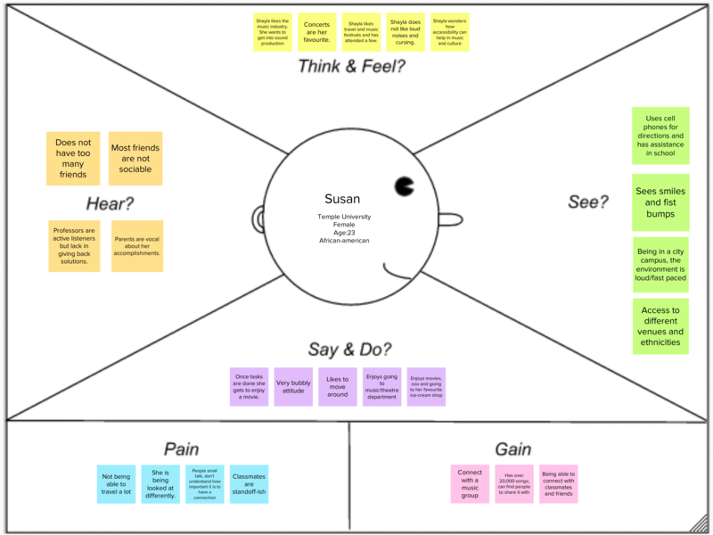

* 1. **Ideation & Brainstorming Map**

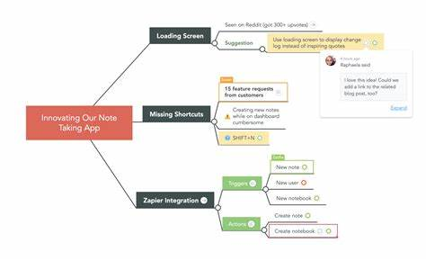

# 3 RESULT

* 1. **Data Model**

|  |  |  |
| --- | --- | --- |
| **Object Name** | **Fields in the Object** | |
| **Field label** | **Data Type** |
| **School** | **Address** | **Text Area** |
| **District** | **Text Area** |
| **State and School** | **Text Area** |
| **Phone Number** | **Phone** |
| **Number of Students** | **Roll up Summary** |
| **Highest Marks** | **Roll up Summary** |
| **Student** | **Phone Number** | **Phone** |
| **School** | **Master-Detail Relationship** |
| **Results** | **Picklist** |
| **Class** | **Number** |
| **Parent** | **Parent Address** | **Text Area** |
| **Parent Number** | **Phone** |

* 1. **Activity & Screenshot Milestone 1:**

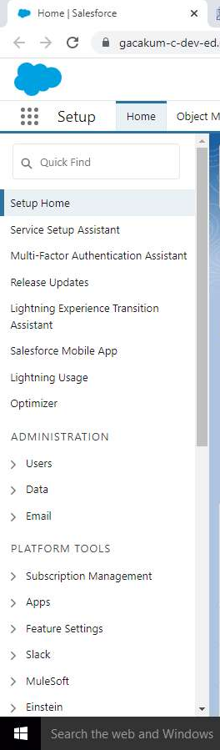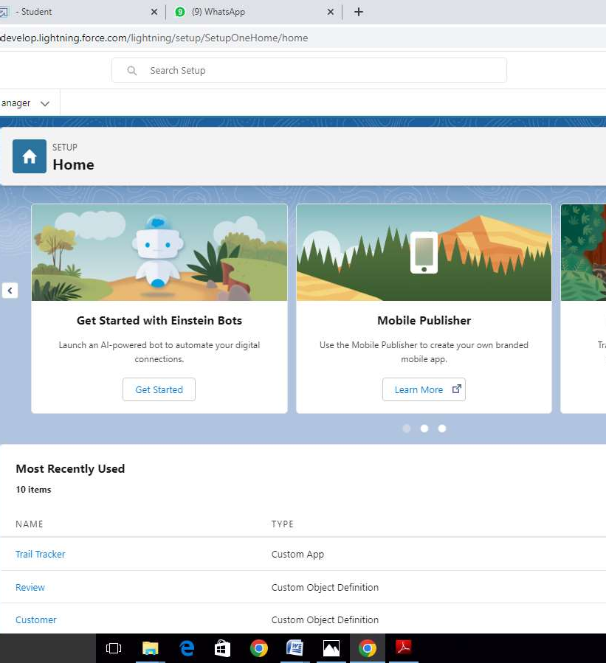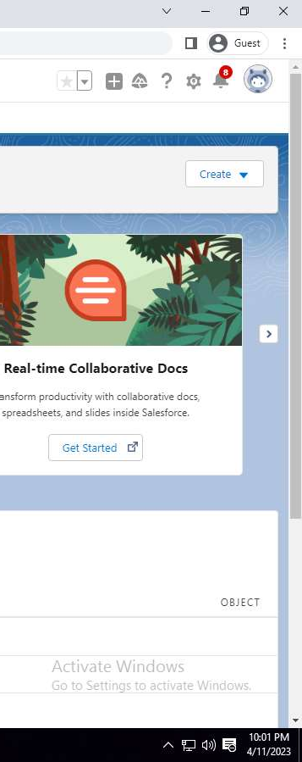

**Creation of Salesforce Account.**

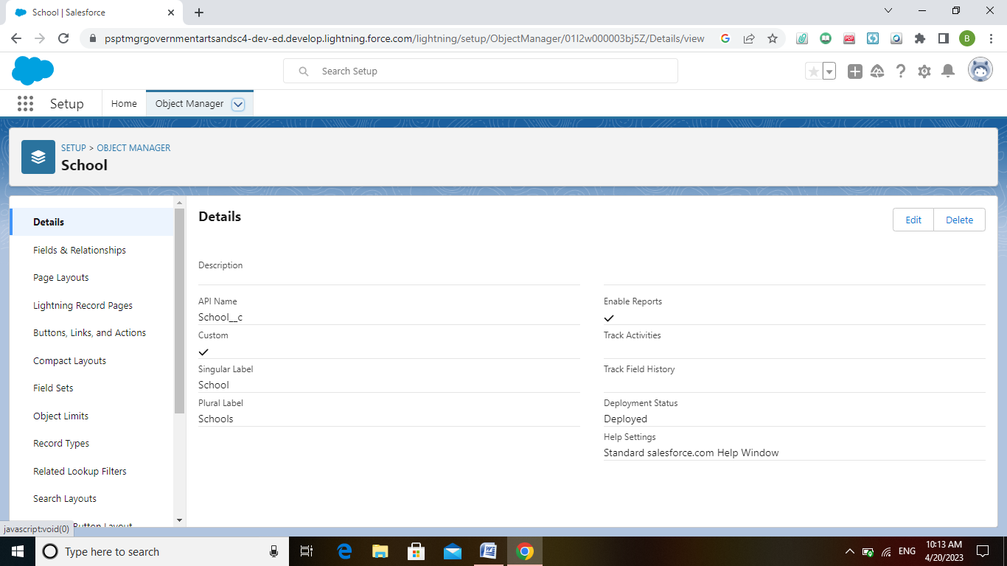 Milestone :2

Creating Object for School Student and Parent

Milestone 3:

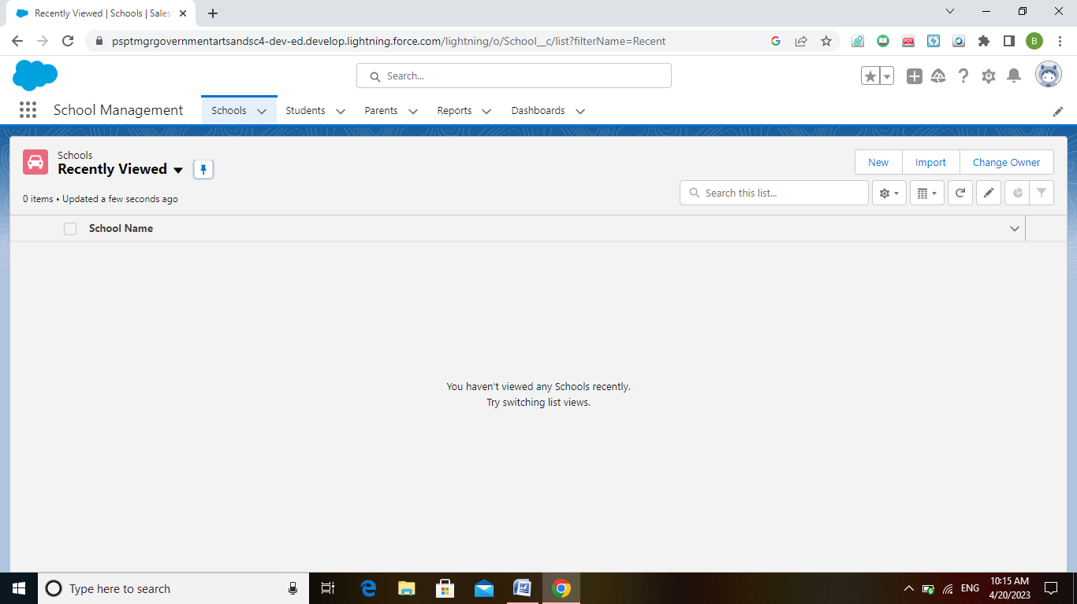

Creation of lightening app for School Management

Milestone 4 :

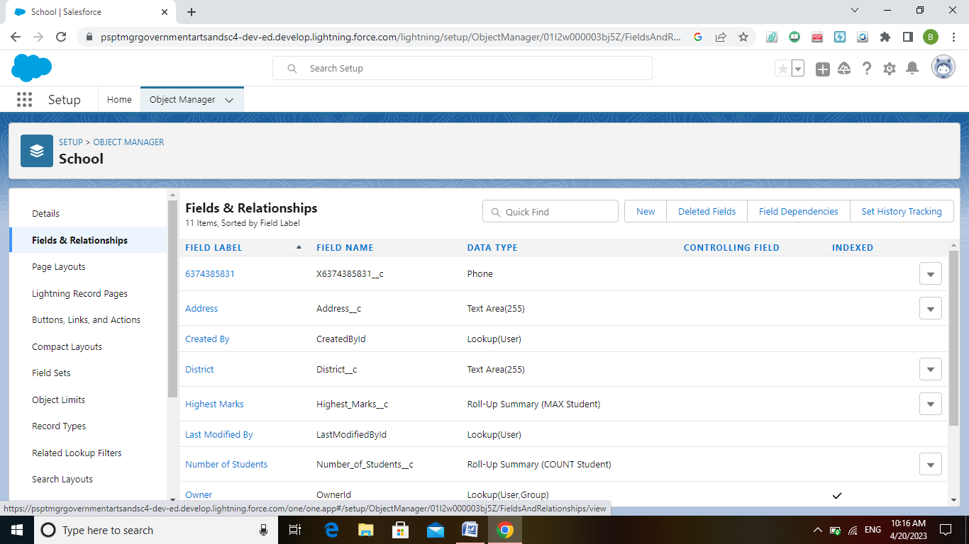

**Creation of field and Relationship for the objects school, students and parents.**

Milestone 5:

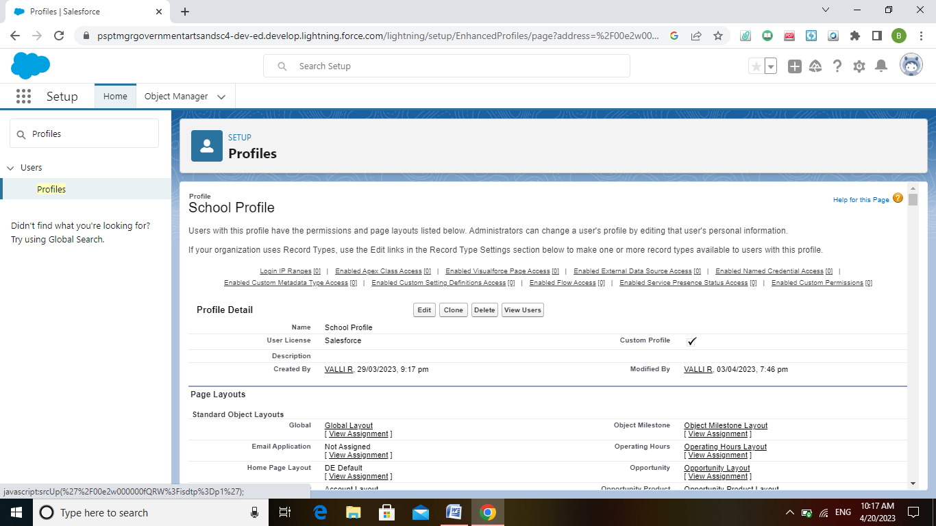

**Creation on profile for school**

Milestone 6:

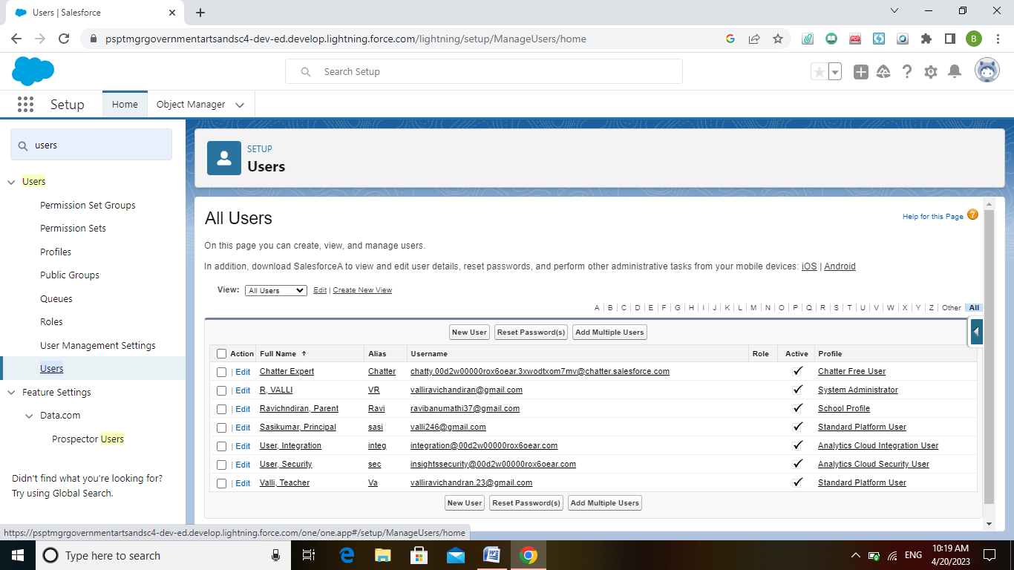

Creating users for Teachers, Principal and Parents

Milestone 7:

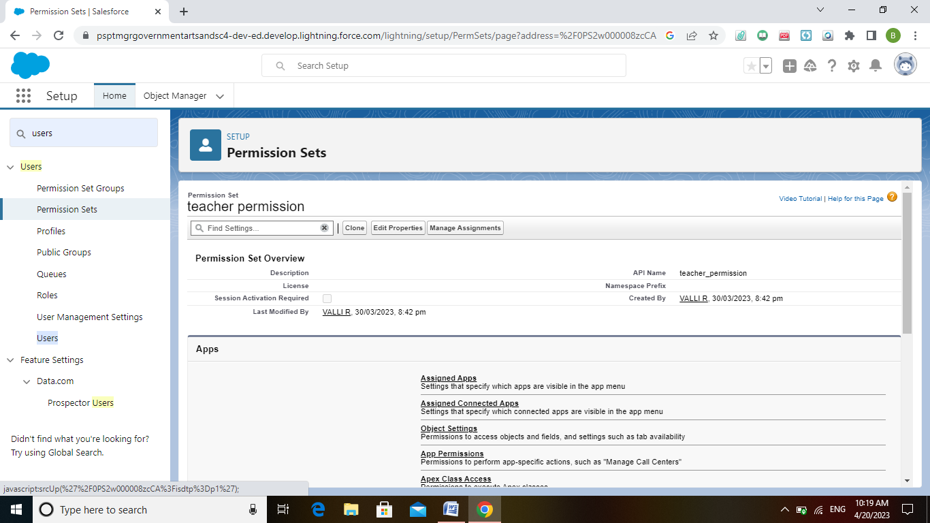

Creating permission set for teacher permission and principal permission

Milestone 8:

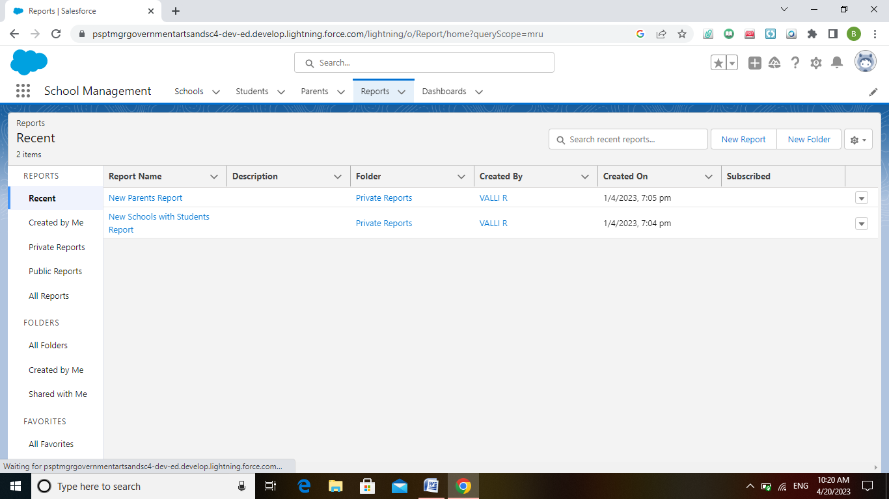

Creating report for school with students and parents

# 4 TRAILHEAD PROFILE PUBLIC URL

Team Lead - <https://trailblazer.me/id/vallr2>

Team Member 1 - <https://trailblazer.me/id/subashiniabcd>

Team Member 2 - <https://trailblazer.me/id/tsenguttuvan>

# 5 ADVANTAGES & DISADVANTAGES

* It is useful for manage school records.
* It is handle by all the persons of the Institution.
* Less expenses for creating this app.
* It is not a popular in all countries.

# 6 APPLICATIONS

* It used in all schools for managing records about student and their parents.
* It helps to pick a more data about the student..
* Mostly it is used for a big schools.

# 7 CONCULUSION

* To enhance the efficiency of the app.

# 8 FUTURE SCOPE

In the 21st century each and every field is computerized and all works are done by using the modern technologies so it has a good future.